Name: ______________________________________ | Date: ___________________


Part 1: Cheerleading Headgear Assessment

Protecting Athlete's Heads and Brains While Cheerleading
Many sports require or recommend helmets for protecting athletes’ heads and brains. There are helmets for biking and skateboarding, helmets for baseball and football, helmets for rock climbing, and some people are even recommending headgear for soccer players. All of these are intended to prevent damage to the head or brain in the event of a collision.

There are sports people participate in like basketball, soccer, and cheerleading where helmets or headgear are not required even though concussions and other head injuries happen often. In cheerleading, concussions are very common. At least ⅓ of all injuries in cheerleading are concussions, usually from falling or head contact with the floor. In one recent year of college sports, the cheerleaders at the University of Georgia had a higher rate of concussions than the football or soccer players. How could cheerleaders protect their heads during competition?

Watch the video with your class to see the kinds of movements that the cheerleading athletes experience.

Part 1: Evaluating headgear

Here are three different headgear devices that are currently being marketed as protection from potential concussions in cheerleading.
 | 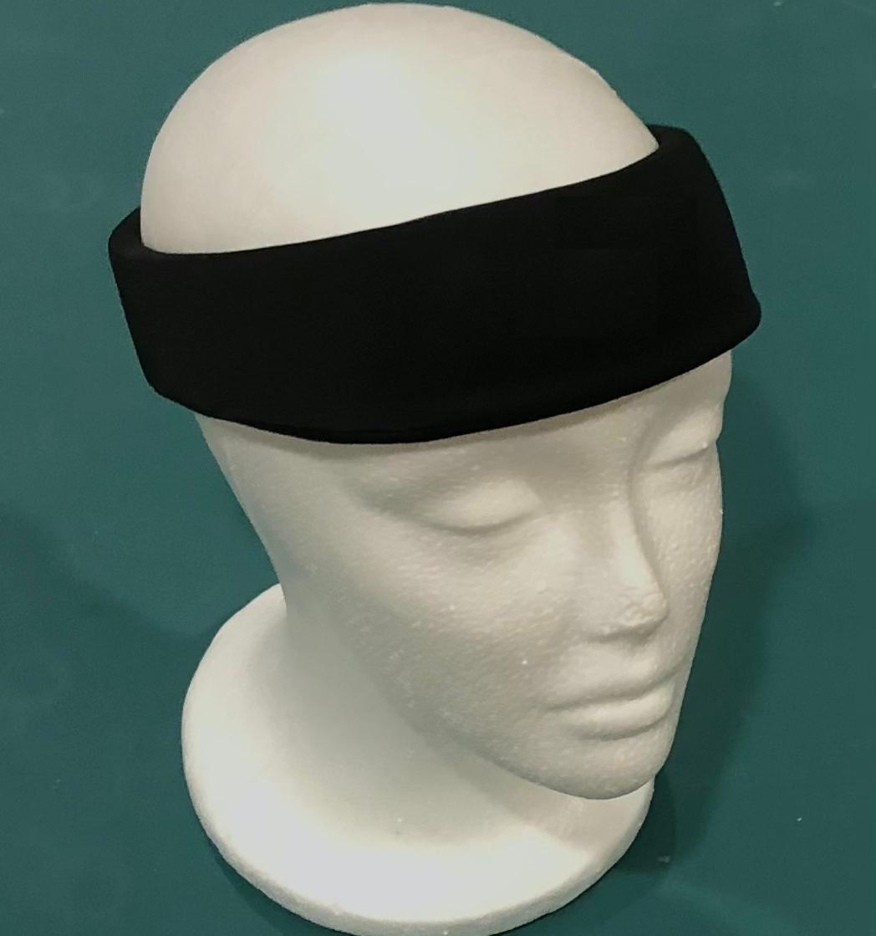 | 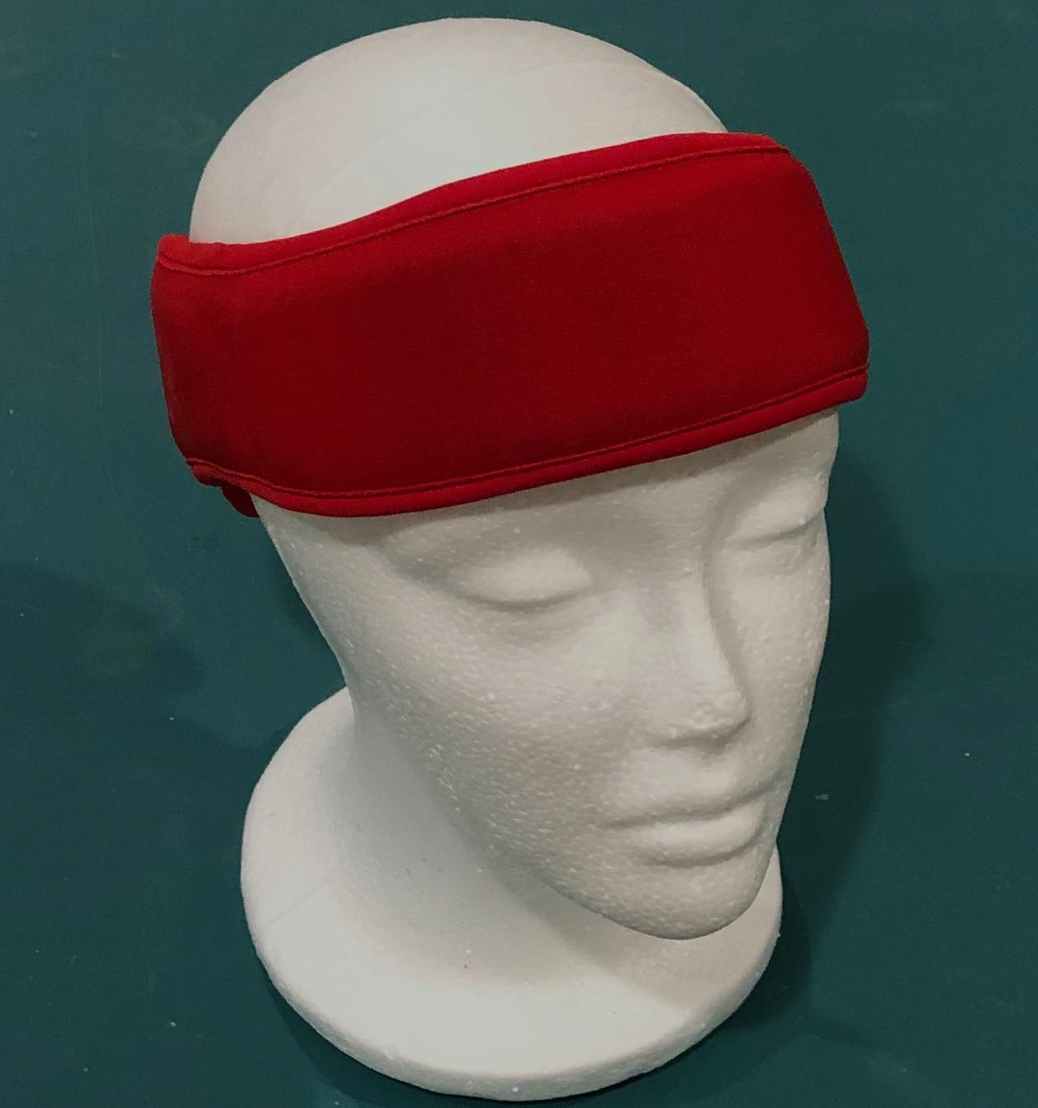
  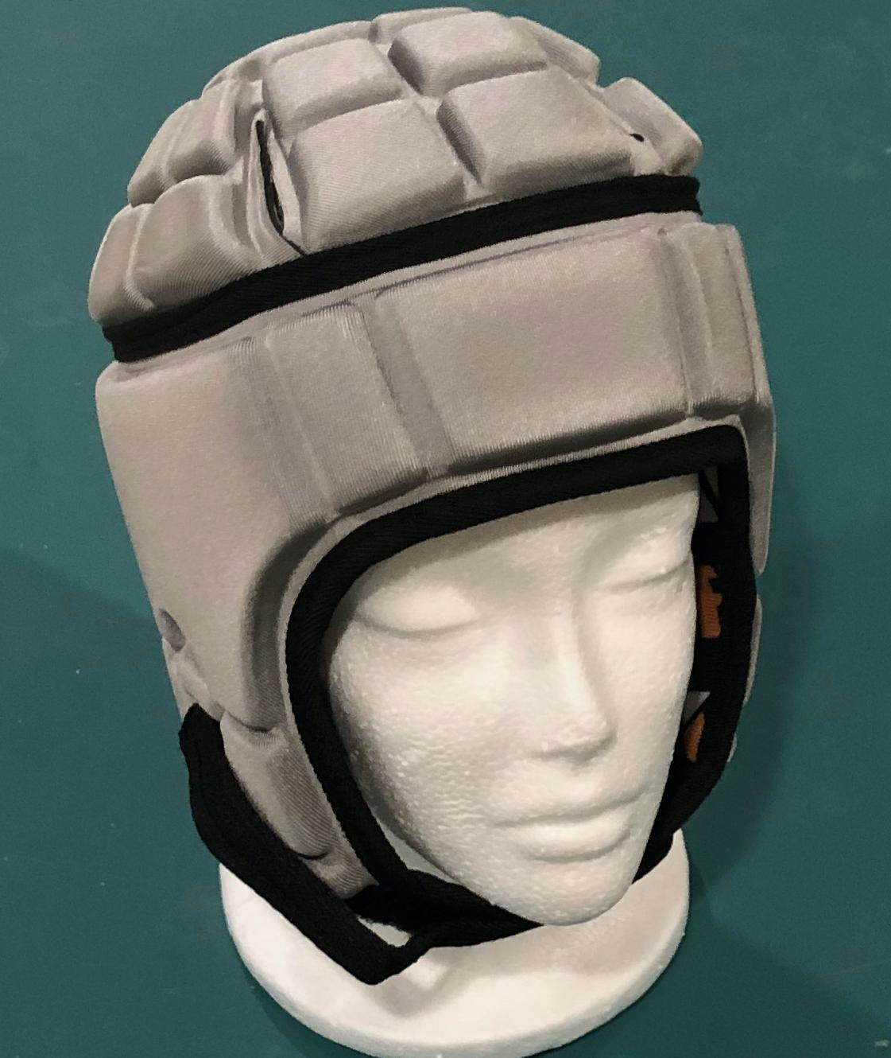
Design #1 | Design #2 | Design #3

The headgear devices shown above were initially designed for other sports, and then people started using them for cheerleading.

1a. If you were a protective headgear device designer evaluating the materials being used in another company’s design, what properties or materials would you expect to see in a good protective device if it were cut open?

1b. Draw a model of the material structure you would expect to see in the design described in 1a. In your model, label each design feature. For each design feature you label, explain in words how the structural properties help it function as a protective material.

2a. When any of the three designs shown above are worn on a person's head, the person’s head is in contact with the headgear. When a person falls to the floor and hits their head, the headgear makes contact with the ground.

Draw and label a diagram that shows all three of these objects (head, headgear, ground) in contact with each other at the point in time when the collision with the ground first starts.

2b. Draw three free body diagrams, one for each object in your system in 2a. Include the following details in each diagram:
- Show the strength of the forces applied to each object in the system.
- Label what is applying this force to that object.
- Show the direction of these forces.
- Label the surface they are applied to.

3a. During practice, a flyer (a person launched into the air) does not want to wear their headgear. Another member of the squad, a base (a person who launches the flyer and stays on the ground), asks the flyer to wear their headgear because it will not only protect the flyer, but it will also further protect the base if their heads collide. Do you agree or disagree with this claim?

3b. Support or refute this claim by citing evidence from investigations we did and using any related science ideas we developed to defend your argument.

